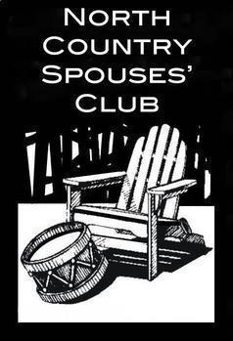

The North Country Spouses’ Club is pleased to be able to provide financial assistance to deserving nonprofit organizations in accordance with the rules and regulations established by the NCSC Community Outreach Committee and our Constitution and By-Laws.

The North Country Spouses’ Club is now accepting grant applications! Email your cover letter (on organizational letterhead) and application as an attachment on or before April 7, 2023, to: NCSCcommunityoutreach@gmail.com. A cover letter is required. Please put “2023 Outreach Grant Application” in the subject line. Email is the preferred submission method.

If sent by mail, applications must be postmarked by April 7, 2023. Please send an email notification if you are mailing your application. Applicants will receive confirmation of receipt of their application. If you do not receive confirmation, please contact the Community Outreach Grants Chairperson at the email listed above. It is the responsibility of the organization requesting the grant to ensure the application has been received.
North Country Spouses’ Club
PO Box 327 Fort Drum, NY 13602
Attn: Community Outreach

The Community Outreach Grants committee will review all applications received by the deadline, and applicants will receive notice of approval or disapproval by April 30, 2023.
If funds are not available for all items, NCSC may be able to fund a partial request. The money used to fund grant requests is derived from fundraising efforts during the club year; the amount varies yearly.

Application for Community Outreach Grant 2023

Date of Application:

Name of Requesting:

Organization:

Name of Point of Contact and email address:

Address and Phone Number:

Amount Requested:

Brief Statement of Mission of Requesting Organization:

Specific Purpose of funds requested (Please be as specific as possible):

The number of people who benefit from the organization or program and how many of these members are military/military family members:

In what way will this request support the members of the Fort Drum community and/or their families?

What are your current budget expenses for this project, and what income have you received to date, if any?

Is your organization eligible for appropriated or non-appropriated funds for the purpose of this request? If yes, please explain why such funds are insufficient for this purpose.

Please list any other actions your organization took to raise funds, if appropriate.

What is the impact on the organization if this request is not granted?

Our mission is as follows: “The purpose of the organization shall be to develop and foster a spirit of community responsibility at Fort Drum, to provide welfare, to provide opportunities for social, cultural, and creative pursuits, and to support worthwhile service and community projects.”

How does your organization’s request embody our mission?

If there is any other information about your organization that members of the NCSC Community Outreach Grant Committee should consider, please state.
To whom should the check be made payable (cannot be an individual)

If you should be awarded a grant from NCSC, all checks awarded must be cashed or returned to the NCSC within 60 days of check issuance. Please forward any further questions to NCSCcommunityoutreach@gmail.com. The application deadline is April 7, 2023.

